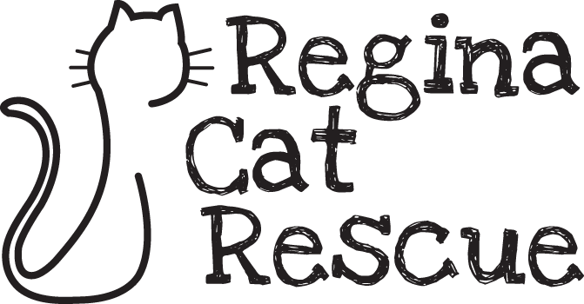
Board of Director Role: Treasurer
If you have a passion for cats, are a whiz with numbers, and are excited about the opportunity to give back to a local not for profit, this might be the volunteer opportunity you’ve been searching for!

Role Summary
The Treasurer is a key role on the Regina Cat Rescue’s (RCR) Board of Directors. This volunteer Board role oversees RCR’s financial matters in line with best practice and in accordance with the governing documents and legal requirements. This Board role is responsible to regularly report to the rest of the Board regarding the financial health of the Rescue.

The Treasurer will ensure effective financial measures, controls and procedures are in place for RCR.

Key Responsibilities
- Overall responsibility for the funds of RCR; ensures a full and accurate account of all assets, liabilities, receipts, and disbursements for RCR are kept in the Corporation’s books
- Guides the financial related activities of staff and contractors including the Operations Manager and Bookkeeper
- Submits financial statements for review and discussion at Board Meetings; makes recommendations to guide the financial health of the Rescue
- Submits an annual report at the Annual General Meeting that includes revenue and expenditure statements and a balance sheet
- Oversees matters to retain charitable status with the Canadian Review Agency; includes filing the corporate tax return and corporate information return
- Ensures tax receipts are written for eligible donations
- Prepares and oversees the budget
- Chairs the Finance and Revenue Development Committee
- Performs other duties as assigned by the Board of Directors

Ideal Candidate
- A CPA or CPA Candidate with 3+ years’ experience in accounting or finance.
- Previous experience serving on a not-for-profit board is an asset.
- High level of integrity and ethics.
- Extremely organized.
- Keen eye for detail.
- Passionate about the welfare and well-being of cats.

The Treasurer must provide a Criminal Record Check to hold this volunteer role. They must also purchase and maintain an annual RCR membership during their term on the Board.

If you’re interested in this volunteer board position, please submit your resume to secretary@reginacatrescue.com.

